Tarrytown
Neighborhood Meeting
To discuss:  - Traffic Calming Proposals  - Impact on the neighborhood  - Permanent change of the streets  - Safety of our children  - Future Initiatives | 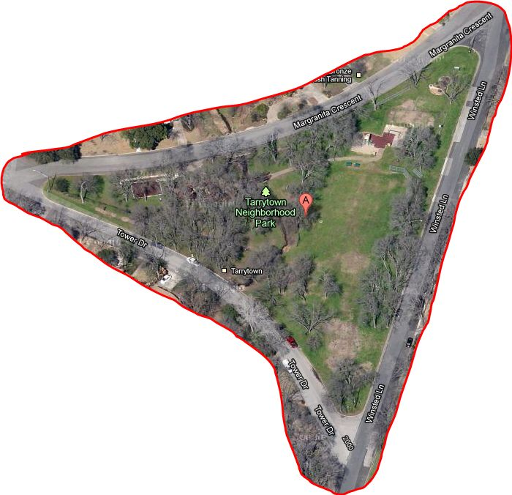
Please Join Us . . .
Date |  | Time | Place
Monday, November 28th |  | 6:00 pm | Howson Library

